Milestone 2
- Introduction
This documentation is comprised of implementation ready structure for the Milestone 2 design. This includes what the architecture is about, how the networking structure is going to look like, what databases are created, which IAM roles and permissions are given and for what, along with the flow of each service that are being used.

- Architecture and Technical Decisions
The approved architecture is a backend architecture which starts with the lambda authorizer function that validates the credentials which are stored in the SSM Parameter Store, and redirects to its services based on the role. Later, the whole architecture is comprised of four lambda functions with only one database that has all the tables, including the customer details and having one EventBridge bus.
  - Lambda function URL vs API Gateway
It is a well-known fact that API Gateway is mostly chosen for authorizing, because of its built in authorizer model and request validation as well. But the project that I’m aiming for is for 100 customers on an average, along with lesser CRUD operations as well. Hence, I’ve decided to invoke the lambda function directly, and storing the authorizer credentials as parameters (key-value pairs), rather than using the API Gateway.
But there is a direct and important tradeoff to consider, i.e., the lambda function doesn’t come with validation, throttling, etc. Hence, a Lambda Authorizer in this project is never described as an API Gateway authorizer; there is no API Gateway to attach one to. The Function URL is the boundary, and the Lambda itself owns everything that happens after the request lands.
  - Asynchronous vs Synchronous Order Processing
While processing an order, it is important to consider any kind of problems that they are facing. No matter how many customers we have, if you are working on an e-commerce platform, it is necessary to make sure that no customer is waiting for their order. Whatever status it might be, it has to be sent immediately. For this, using Synchronous Order processing is never recommended, hence using Asynchronous Order processing is the optimal choice.
Benefits of using Asynchronous Order Processing is that it helps in reducing the traffic, the waitlist, as a result, giving a seamless opportunity for the customers/users to use.
  - RDS MySQL vs DynamoDB
DynamoDB was considered to be used in this project, but while looking into the tables created and the relation that each table has with the other tables made me reconsider the decision to use RDS instead of DynamoDB.
As much as DynamoDB is flexible and is used all over, yet, RDS is now being considered, because of its structure, along with the keys that it has. The keys help in forming a relation between tables.
  - Idempotency table
The entire reason the idempotency_keys table exists: before the processor deducts stock or completes an order, it checks whether that idempotency key has already been processed, and if it has, the message is acknowledged without repeating the side effects.
Once the configured maximum receive count is exceeded, the message moves to the Dead Letter Queue instead of retrying forever. This can be done by storing the idempotency keys in a separate table.

  - EventBridge
EventBridge acts as a bridge to proceed with after all four lambda functions. And it is a well-known fact that this helps in generating the report lambda function. Hence, it doesn’t reside in any stack, it has its own stack (which is an event bus). It also helps in generating the timestamp for adding in the tables. It takes the timestamp from the event generated time, along with the CloudWatch logs for a more precise timestamp and stores it in the respective tables.

- VPC and Networking
  - CIDR and Subnet Structure
All the Lambda and RDS are sharing a single subnet, i.e., a private subnet along with showing the EC2 dashboard, hence it needs a public subnet. Hence, I’m using a /16 VPC with /24 subnets, which are private subnet and public subnet.
Network | CIDR
VPC | 10.0.0.0/16
Public Subnet | 10.0.1.0/24
Private Subnet | 10.0.2.0/24
  - Security Group Rules
There are three security groups that are being contributed to the architecture, namely Lambda SG, RDS SG, VPC SG.
For a Lambda SG, it doesn’t accept any kind of inbound VPC, it has no inbound rules. Coming to the outbound rules, one port to reach the RDS MySQL (to the RDR SG), and another to the EventBridge, along with SSM and SQS, SNS services (to the VPC SG).
For a RDS SG, it needs an inbound rule from the Lambda SG, i.e., to reach the Lambda functions directly. Since the RDS is confidential, it is permitted to have access only through the lambda functions. When it comes to the outbound rules, maintaining the default is better, since there is no outbound restriction for the RDS.
For a VPC SG, it only needs an inbound from Lambda SG, since I’m planning to make it accept from the lambda only for accepting the HTTPS requests.
  - VPC Endpoints
The project needs a Gateway endpoint for lambda function to write the .csv files into the S3 bucket and since it’s free, it’s not an issue to use it effectively.
Coming to the Interface Endpoints, the project needs an endpoint to connect with the SSM parameter store for lambda function to get the configuration details, an endpoint to the EventBridge for publishing events into the event bus, an endpoint to the SNS for notifications, alerts, etc and lastly another endpoint for SQS services as well to act as a barrier from the orders lambda to the order processing lambda functions.
  - Tradeoffs
VPC Endpoints add resources and a small amount of extra CloudFormation to write, compared to a single NAT Gateway that would cover every outbound call generically. As much as NAT Gateway bills hourly, it is an effective option for managing the endpoints. But since my project aims for cost-effective design, the Endpoints are used.

- CloudFormation Stack Design
The stacks that are being used in my project are
- Network stack
- Database stack
- Storage stack
- Eventbus stack
- Product stack
- Order stack
- Order processing stack
- Report stack
- Monitoring stack
This is the order of deployment as well. When it comes to where each stack’s exports are being used, the following table shows how each stack is being used and where.
Stack Name | Exports | Used for
network-stack | VPC ID, Subnet IDs, SG IDs | Placing RDS instance, for every lambda, EC2 instances for the subnets and security groups
database-stack | RDS endpoint addresses, port, database names | Writing in the lambda functions, to show in the EC2, configurations for SSM connection
storage-stack | Report bucket name, bucket URN | Report lambda’s write permission, EC2 dashboard read permission, S3 metrics in the dashboard
eventbus-stack | Event bus ARN, name | It is linked with all lambda’s put permission
order-stack | SQS queue URL and ARN, DLQ ARN | Order processing lambda’s mapping, DLQ alarms
Product-stack, order-stack, order-processing-stack, reporting-stack | Lambda ARNs, Function URLs, EC2 instance’s public DNS name | CloudWatch metrics, widgets, alarms and dashboard link on the operations page
Exports help in understanding what each stack is giving, and this table describes how each stack helps in other stacks as well.
It also makes the dependency graph visible just by reading the exports — anyone looking at order-processing-stack's imports can immediately see that it depends on order-stack and eventbus-stack without having to read the Lambda code first.

- IAM and Security Design
  - IAM Roles
There are five roles that are being created, and each one plays a significant role in the lambda functions.
- Product Lambda role: Reads and writes only products and categories tables in RDS, read the SSM parameters, publish the events, SNS, and read SSM parameters as well.
- Order Lambda role: Read customers, addresses and products; write orders and order_items; write to the idempotency_keys table; send messages to the order SQS queue; read SSM parameters.
- Order processing Lambda role: Consume from the order SQS queue, read and write orders, order_items, order_status_history and inventory_transactions; publish EventBridge events; publish to the order-confirmation SNS topic; read SSM parameters.
- Report Lambda role: Read from RDS, write objects to the reports S3 bucket, read SSM configuration, write logs and metrics.
- EC2 dashboard instance role: Read-only access to the reports S3 bucket, read-only access to the required RDS summary data, read the relevant SSM parameters, and write logs/metrics — attached as an instance profile rather than a Lambda execution role, but scoped with the same least-privilege standard as every other role in this list.
Each compute resource keeps its own role rather than sharing one, since the roles above genuinely do not overlap — the Report Lambda has no business writing to orders, the Product Lambda has no business touching S3, and the EC2 dashboard has no business writing to anything at all; every one of its permissions is read-only. No role in this system uses a wildcard action or a wildcard resource.
  - SSM and Secrets Management
Even the database credentials are stored in the SSM Parameter Store and Secrets Manager. There are three types of storing the SSM parameters and in my project, I’m using SecureString and String, since the other type, Text is not needed in this.
SecureString stores the confidential details such as database password and authentications secrets.
Whereas String stores the hostnames, URLs, bucket names, environment names, thresholds, etc.
  - Function URL Security
It is the direct HTTP boundary, hence there is no authorizer accessing this. If there is any error while logging in, be it login credential fault or incorrect credentials, the status code is 401 (Unauthorized). Function URL auth type is set to AWS_IAM only where that is the intended invocation model, or NONE with the Lambda doing its own token check — anonymous invocation is never left on by accident.

- Data Models
  - RDS Design Principles
The RDS has all the below tables listed and connected in a single database.
  - ER Diagram
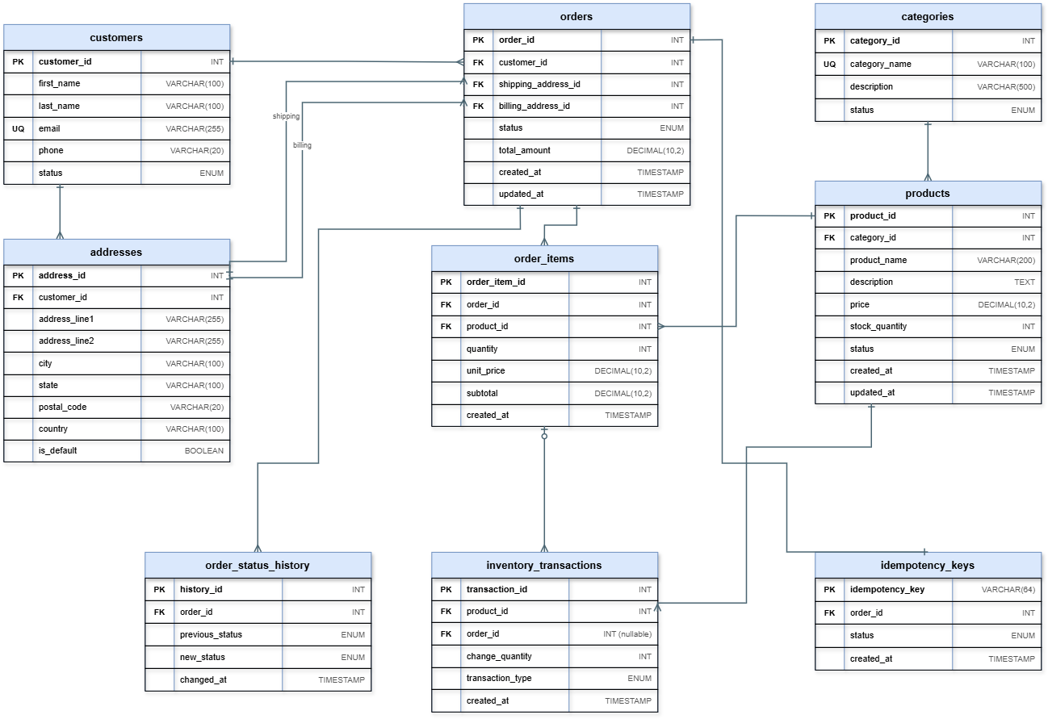

- Configuration Structure
  - Naming Convention
Every parameter follows the same shape, so any Lambda can construct the path it needs to read without a lookup table:
/cloudmart/{environment}/{service}/{parameter}
- There are two types of environments that I’m using, dev and prod.
- Services are database, order, s3, eventbridge, inventory, auth.
- And for every service, there are dedicated parameters.
  - Parameter Convention
As mentioned before, I’ve used two types of parameter types, which are SecureString (to store confidential names and tokens) and String (to store names, databases, etc).
  - Low Stock Threshold
The low-stock threshold is 10, since I am aiming to maintain same stock for all of the products. If the product’s stock falls below the threshold, the LowStockEvent gets triggered and gets published.

- Environment Parameterization
As mentioned in the above, the same CloudFormation templates deploy both dev and prod; only the parameter values change. Environment-specific differences are supplied through CloudFormation parameters, which then drive the SSM path convention above. Every resource name includes the environment, so a mistaken cross-environment reference fails loudly at deploy time rather than silently at runtime. Dev and prod each get their own S3 bucket, queue, RDS instance, SSM parameters and Function URLs. No application code contains an environment-specific resource ID; everything is resolved through SSM or an environment variable set at deploy time.

- API Request and Response Contracts
  - Product API
POST /products
- Purpose: Create a product
- Success: 201 Created
- Error responses: 400, 401, 403, 409, 500
GET /products/{productId}
- Purpose: Get one product
- Success: 200 OK
- Error responses: 400, 401, 404, 500
GET /products?category_id=&status=
- Purpose: List/filter products
- Success: 200 OK
- Error responses: 400, 401, 500
PUT /products/{productId}
- Purpose: Update product fields, including price and stock corrections
- Success: 200 OK
- Error responses: 400, 401, 403, 404, 409, 500
DELETE /products/{productId}
- Purpose: Deactivate a product
- Success: 204 No Content
- Error responses: 400, 401, 403, 404, 409, 500
For example,
Request body (POST and PUT):
{"product_name": "Wireless Mouse", "description": "2.4GHz wireless mouse", "category_id": 3, "price": 799.00, "stock_quantity": 45, "status": "ACTIVE"}

Success response — POST /products (201):
{"success": true, "data": {"product_id": 118, "product_name": "Wireless Mouse", "category_id": 3, "price": 799.00, "stock_quantity": 45, "status": "ACTIVE"}, "request_id": "a1b2c3"}

Error response — example, category does not exist (400):
{"success": false, "error": {"code": "INVALID_CATEGORY", "message": "category_id 3 does not exist", "details": []}, "request_id": "a1b2c3"}
  - Category API
POST /categories
- Purpose: Create a category
- Success: 201 Created
- Error responses: 400, 401, 403, 409, 500
GET /categories
- Purpose: List categories
- Success: 200 OK
- Error responses: 401, 500
GET /categories/{categoryId}
- Purpose: Get one category
- Success: 200 OK
- Error responses: 400, 401, 404, 500
PUT /categories/{categoryId}
- Purpose: Update a category's name/description
- Success: 200 OK
- Error responses: 400, 401, 403, 404, 409, 500
DELETE /categories/{categoryId}
- Purpose: Deactivate a category
- Success: 204 No Content
- Error responses: 400, 401, 403, 404, 409, 500
Note: Deleting a category that still has ACTIVE products attached to it is rejected with 409 Conflict rather than silently orphaning those products' category_id. The operator has to either reassign or deactivate the affected products first.
  - Customer API
GET /customers/{customerId}
- Purpose: Get one customer
- Success: 200 OK
- Error responses: 400, 401, 404, 500
GET /customers/{customerId}/orders?status=
- Purpose: List a customer's orders — this is how order history is retrieved
- Success: 200 OK
- Error responses: 400, 401, 404, 500
PUT /customers/{customerId}
- Purpose: Update a customer's contact details
- Success: 200 OK
- Error responses: 400, 401, 403, 404, 500
  - Order API
POST /orders
- Purpose: Create an order and enqueue it for processing
- Success: 202 Accepted
- Error responses: 400, 401, 403, 404, 409, 500
GET /orders/{orderId}
- Purpose: Get an order with its items
- Success: 200 OK
- Error responses: 400, 401, 403, 404, 500
GET /customers/{customerId}/orders
- Purpose: List a customer's orders
- Success: 200 OK
- Error responses: 400, 401, 403, 404, 500
PUT /orders/{orderId}/cancel
- Purpose: Cancel an eligible order
- Success: 200 OK
- Error responses: 400, 401, 403, 404, 409, 500
For example,
Request body (POST /orders):
{"customer_id": 88, "shipping_address_id": 12, "billing_address_id": 12, "idempotency_key": "a-client-generated-uuid", "items": [{"product_id": 118, "quantity": 2}, {"product_id": 41, "quantity": 1}]}
Success response (202 Accepted) — total_amount is calculated server-side and never taken from the client:
{"success": true, "data": {"order_id": 1042, "status": "PENDING", "total_amount": 2497.00}, "request_id": "d4e5f6"}
  - Order Cancellation Rule
Only orders that has status as Pending or Processing are allowed to be Cancelled. If inventory has already been deducted, cancellation writes a matching inventory_transactions row to restore it, and that restoration is idempotent for the same reason order processing is.

- CI/CD Workflow Steps
Before pushing them all to GitHub and looking at the actions flow, it is important to connect AWS with GitHub for it to use the AWS Console. For that, I’ve created an identity provider that uses my GitHub repository and my file as the source from which the codes are pushed into AWS. Then I’ve created a IAM user that is used by GitHub. Later the GitHub action flow would go in the following order:
- Checkout source code.
- Install dependencies.
- Run linting and static checks.
- Run unit tests.
- Package each Lambda function separately.
- Validate every CloudFormation template.
- Deploy network-stack.
- Deploy database-stack.
- Deploy storage-stack.
- Deploy eventbus-stack.
- Deploy product-stack, order-stack, order-processing-stack and reporting-stack (including the EC2 dashboard's UserData bootstrap).
- Deploy monitoring-stack.
- Read the exported Function URLs from stack outputs.
- Run smoke tests against the deployed Function URLs.
- Publish the deployment result.
For every type of request, it gives the status codes (like 400, 401, 404, 409, 202, etc) and the order processor moves the order to COMPLETED and deducts stock correctly. Sending the same idempotency key twice does not deduct stock twice. A deliberately failing message ends up in the DLQ after the configured retries. EventBridge events are actually published for order and low-stock outcomes, each with a valid event_time.

- Custom CloudWatch Metrics
The CloudWatch metrics that I’ve considered are OrdersPlaced (which gets incremented whenever an order is accepted and queued), OrdersFailed (which gets incremented when an order permanently fails) and LowStockEvents (which gets incremented when low-stock threshold is crossed or triggered).
Whenever the condition is crossed or triggered, the metrics are being published. These custom metrics stay separate from the native Lambda metrics like Invocations, Errors and Duration, which CloudWatch already provides without any code.
- Error Handling Strategy
  - Error Classification
Status Code | Condition
400 Bad Request | Invalid JSON, missing fields, or validation failures.
401 Unauthorized | Missing, invalid, or expired authentication token.
403 Forbidden | Caller lacks necessary resource permissions.
404 Not Found | Referenced entity does not exist.
409 Conflict | Business rule conflict (e.g., duplicate key, invalid state change).
500 Internal Error | Unhandled runtime or downstream system failure.
503 Unavailable | Transient dependency outage; client should retry.

  - Logging & Observability
- Traceability: Every request attaches a request_id shared across logs and responses for end-to-end tracing.
- Context & Sanitization: Logs capture function names, entity IDs, and execution outcomes while strictly redacting secrets and tokens.
- Error Isolation: CloudWatch stores full stack traces, returning only safe error codes to clients.
  - SQS Retries & DLQ
- Failure Routing: Transient faults trigger standard SQS retries, whereas permanent domain failures (e.g., out of stock) immediately mark the order as FAILED.
- DLQ Monitoring: Poison messages route to the DLQ after exhausting retries, alerting via CloudWatch.
  - Idempotency
- Dual-Layer Defense: Client idempotency keys prevent duplicate API calls, while consumer-level checks protect against SQS duplicate deliveries.
- Transactional Deductions: Inventory updates and terminal status changes execute atomically in one database transaction.
  - Persistence & Events
- Atomic Rollbacks: Any database step failure triggers a full rollback, masking internal errors behind standard 500/503 responses.
- Reliable Eventing: EventBridge publish failures on critical domain events block and retry the operation rather than failing silently.

- Conclusion
This document establishes the comprehensive backend architecture and technical design for CloudMart, finalizing all architectural decisions, network topology, CloudFormation stack dependencies, relational schemas, API contracts, CI/CD pipelines, and error-handling strategies required before implementation begins.
Every design choice—such as opting for Lambda Function URLs over API Gateway, RDS over DynamoDB, and VPC Endpoints over NAT Gateways—was evaluated against its tradeoffs to ensure the system is proportionate, secure, and unambiguous. By resolving all infrastructural and data modeling questions upfront, subsequent milestones can focus entirely on code execution rather than retroactive system discovery.
The architecture established here serves as the baseline for all upcoming milestones, from authentication and core APIs to asynchronous order processing and observability. With the design finalized and cross-stack dependencies locked in, the backend architecture is ready to transition directly into the implementation phase.

